Probecell J. Adv. Pharm. Sci., 2026;1(1):01-12
 | PROBECELL JOURNAL OF ADVANCED PHARMACEUTICAL SCIENCES (PJAPS)  Journal homepage: https://pjaps.com | 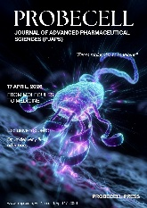

Recent Advances in Microbiome-Driven Ocular Surface Health: Metabolic and Microbial Insights Linking Obesity, Dysbiosis, and Dry Eye Disease

Jhakeshwar Prasad
Department of Pharmacology, Shri Shankaracharya College of Pharmaceutical Sciences, SSPU, Junwani - 490020, Bhilai, Chhattisgarh, India

*Corresponding Author: Department of Pharmacology, Shri Shankaracharya College of Pharmaceutical Sciences, SSPU, Junwani - 490020, Bhilai, Chhattisgarh, India

E-mail Address: jhakeshwarprasad03@gmail.com (Jhakeshwar Prasad)
ORCID: https://orcid.org/0000-0002-9774-4318
ARTICLE INFO | ABSTRACT
ORIGINAL ARTICLE  Received: 08-05-2026  Accepted: 09-07-2026  KEYWORDS  Visual health, gut microbiota, metabolism, nutrition, bile acids | Ocular surface diseases, such as dry eye disease (DED), represent a common pathology in the population and have recently gained recognition as systemic diseases rather than focal diseases. Recent studies have pointed out the role played by an important gut microbiota metabolite-mediated crosstalk in the maintenance of ocular surface homeostasis, particularly in the context of obesity and metabolic derangements. Abundantly documented have been the detrimental impacts of obesity-related nutrient and dietary imbalances to maintain gut microbial diversity and how through systemic inflammation, microbial dysbiosis can also reach the eye and influence pathogenesis in the eye. We here discuss the nascent idea of the gut-eye axis, specifically the ability of metabolites generated in the gut and obesogenic diets to influence aspects of immune function and ocular surface health. Notably, micronutrients (selenium and calcium), which may interact with gut microbiome possibly influence ocular diseases (e.g. thyroid orbitopathy). Common obesity co-morbidity diabetes mellitus also has been associated with alterations in gut and ocular surface microbiota, further supporting a potential association between metabolic health and pathogenesis of ocular disease. An understanding of these interactions could help to identify novel therapeutic targets for which nutritional and microbiome targeting treatments could be synergised for improved metabolic and ocular health. However, there is a need for further research to establish cause and effect and to create nutrition-based interventions in dry eye disease in obese and metabolically disordered populations.

Graphical Abstract:

1. Introduction
Eye surface diseases are one of the most important problems in the public health field in developed and developing countries. Chronic pain, irritation and aesthetic alterations are very expensive for patients, health care facilities, and society [1]. Multifactorial DED is caused by disruption of the balance of the tear film, causing damage to the surface cells and hence injury and inflammation of the ocular surface. Pathogenic intrinsic and extrinsic factors (environmental stressors, age, hormonal changes, systemic involvement and genetic predisposition) can give rise to complex conditions [2]. However, growing evidence indicates that gut (and ocular surface) microbiome dysfunction/autodysbiosis could be a factor in DED. DED prevalence is increasing as demonstrated by epidemiological data. Dry eye is a problem with around hundreds of millions of people around the world. The prevalence studies indicate that 5-35% of people over 50 are affected by DED. Women with hormonal imbalance are known to be more susceptible with regard to metabolism related disorders [3]. The changes in hormones around menopause are adversely affecting women more than men since they reduce the ability to produce tears [4]. Other risk factors include long screen time, air pollution and dry or windy places. Dry eye may be a risk factor in autoimmune disorders such as Sjögren's syndrome and rheumatoid arthritis. DED is a common condition, its pathogenesis is not well understood, and diagnosis and treatment is difficult. Localised inflammation and dysfunction of the ocular surface and symptomatic treatment with artificial tears, anti-inflammatory treatment and punctal plugs have been used in the treatment of DED [5]. More recently, studies have demonstrated that systemic factors, especially the gut microbiome, have an impact on eye health. The gut microbiota consists of one trillion organisms and plays a role in maintaining systemic homeostasis and immunological function and therefore protects health. DED has been associated with a dysbiosis of the microbiome of the human gut. The gut affects the ocular surface through metabolism, immunity and decreased systemic inflammation [6]. There is a unique eye biome. Enhanced suggestive cross talk between gut and ocular microbiome is suggestive of a novel mechanism by which gut metabolites can contribute to ocular health and a connection between gut dysbiosis and ocular surface inflammation and disease. Research into the role played by gut microbiota-derived metabolites in the health of the eye is an interesting topic [7]. Bile acids are another of these compounds produced by gut bacteria which might therefore modulate immune function. These materials may therefore be involved in the pathogenesis of diseases of the ocular surface including DED. A systemic evaluation of systemic health and its relationship with ocular surface diseases would be needed in addition to a local one, with an emphasis on gut microbiota [8]. The concept is new and highly relevant to the field of obesity since obesity is an outbreaking worldwide disease, and inflammatory TNF and metabolic syndrome could be involved in triggering ocular surface diseases such as DED. A better understanding of how changes in gut microbiota associated with obesity impact on eye physiology could lead to new strategies that would allow for a combination of metabolic and nutritional interventions. The article emphasizes on gut microbiome and ocular surface diseases, particularly DED, and the mechanisms whereby gut metabolites affect the eye and to examine how vitamins, omega-3 fatty acids, and minerals affect the gut and eye microbiomes and ocular surface homeostasis that can prevent DED. This review also provides a more in-depth discussion of the manipulation of food and microbiota for prevention and treatment of DED and other ocular surface diseases [9]. Last, this review pinpoints gaps in knowledge about the gut-ocular microbiome axis and highlights the importance of future functional studies to help expand knowledge of the complex gut-ocular microbiome axis, including the interactions between the two microbial communities and their relationship to ocular health, and to define specific, individualized therapeutic strategies.
2. GUT MICROBIOTA AND DRY EYE DISEASE
2.1 Pathophysiology of Dry Eye Disease (DED)
Dry eye disease is a chronic multifactorial disorder of the ocular surface characterized by ocular surface inflammation as a manifestation, and associated with loss of homeostasis of the tear film (loss of meibomian gland function leading to ocular hyperosmolarity) that manifests as dry, irritated, burning, and vision changes. DED is a multifactorial disease, with ocular surface inflammation and damage resulting in a loss of homeostasis of the tear film, and associated with increased ocular symptoms due to a reduction in tear production and increased evaporation. Dey et al. presented that the natural history of DED is highly one of production imbalance and tear film instability and inflammation has significant systemic and local effects in DED disease. DED involves an inflammatory process that leads to an increase of inflammatory cells like T lymphocytes, neutrophils and dendritic cells that break down the barrier between the eye and epithelial cells. The contact lenses, screen time, dry air, and other environmental factors, along with some genetic factors, upsets the immune response. Dry eye, in turn, can be subdivided into aqueous deficient dry eye which is a lack of tears and evaporative dry eye which is caused by meibomian gland dysfunction which results in increased evaporation of the tears [10]. Both subtypes share activation of inflammation and immune dysfunction, but have different etiological mechanisms (Figure 1). Recently, however, research has suggested that the gut microbiome could influence the immune responses involved in DED. The gut microbiota communicates with the immune system through short-chain fatty acids and bile acids, and is also able to influence systemic inflammatory/immune responses. The gut-eye axis, along with the gut-brain and gut-skin axes, also points to a role for changes in the gut microbiota in DED, potentially through systemic inflammation and immunologic homeostasis.

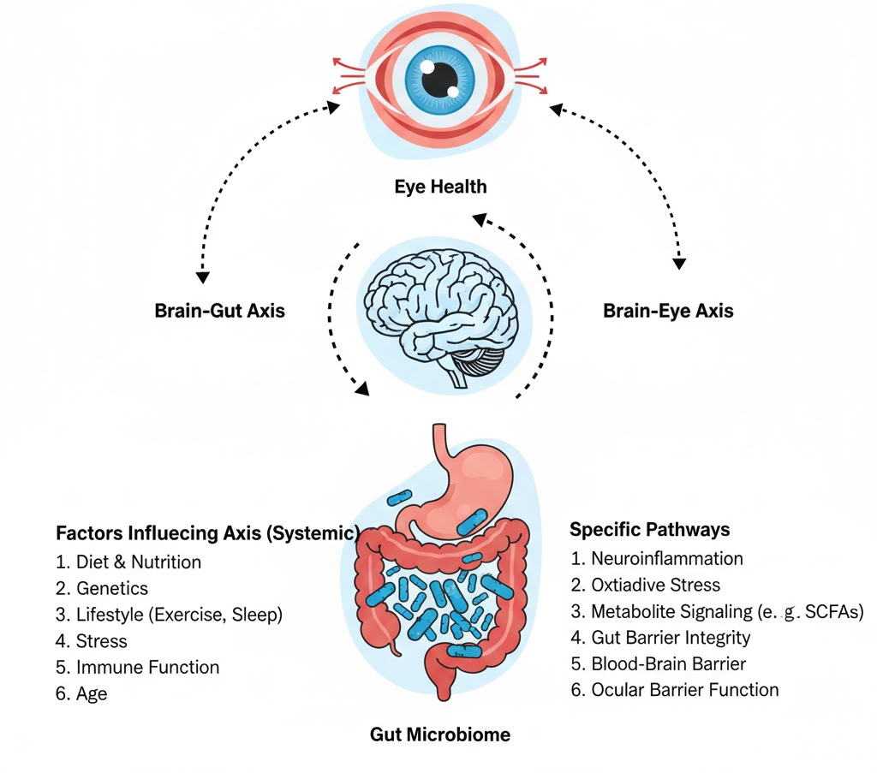
Figure 1 Systemic and molecular pathways linking microbiome dysregulation to ocular health

2.2 Gut Microbiota-Derived Metabolites and Their Effect on DED Symptoms
The gut microbiome produces different compounds which have a variety of effects on local and systemic health. Of the SCFAs, butyrate, propionate and acetate have been studied most regarding their immunological and anti-inflammatory effects (Wang et al., 2023). A glimpse at metabolites which some are metabolites created by gut bacteria from the degradation of dietary fibers which, when absorbed into the blood, can have effects on distant tissues in the body such as the eyes. Butyrate is one of the short-chain fatty acids (SCFAs) that is the central player in regulating an immune response and maintaining the epithelial barrier. As signaling agents, they could also bind to the G-protein coupled receptors of the immune cells to reduce their pathway modulating pro-inflammatory activity [12,13]. In this sense, butyrate was shown to reduce pro-inflammatory cytokines TNF-α and IL-6 [14-16]. However, butyrate has been induced Tregs; Tregs are known as anti-inflammatory cells and help to decrease the inflammation. Because inflammation is a hallmark of the progression of DED, an important role for SCFAs is to prevent or ameliorate diseases associated with inflammation. The SCFAs (butyrate) can maintain the integrity of the epithelial barrier by maintaining tight junctions between epithelial cells [17]. SCFAs can repair the epithelium and restore the barriers in this location-specific ocular surface epithelium injury, and reduce inflammation. Fiber diets (which lead to an increase in SCFA production) are also recommended to promote immune tolerance and to reduce or prevent inflammatory diseases including DED. Products created during the degradative process by the microbiota of the intestine are bile acids and other products, as well as primary metabolites of lipids in the human diet which are the result of degradation by intestinal microbiota [18]. As signaling molecules, bile acids also regulate other biological events such as metabolic regulation, modulation of immune function, and inflammation. These bile acids control systemic inflammation and immunological responses via interacting with nuclear receptors such FXR and TGR5, which modulate systemic inflammation and immune responses. In DED and other autoimmune and inflammatory diseases, there has been a change in the composition of bile acids [19]. Recent research indicates that bile acids could play a role in DED by altering the immune response and the function of the ocular surface. Changes in gut microbiota which lead to dysregulated bile acid pool contribute to systemic inflammation and ocular surface inflammation, worsening DED. In addition, bile acids are potential targets for treatment of DED patients as they have been shown to affect immune cell infiltration and production of cytokines [20].
2.3 Development of DED and Its Connection with Inflammation
Chronic inflammation is a crucial part of DED and plays a role in its etiology. DED is caused by release of pro-inflammatory cytokines by the dry air or contact lenses that bring immune cells to the ocular surface, or by the inflammatory response in autoimmune disorders. The corneal and conjunctival epithelium is injured, resulting in an upregulation of inflammatory cytokines such as IL-1, IL-6, IL-17, TNF-α and MMPs [21]. This leads to the DED pathology to progress to systemically mediated immune responses and to promote epithelial damage and tear film instability. DED pathophysiology includes systemic inflammatory processes that can affect the ocular surface inflammation (Table 1). Gut microbiota has recently been shown to have a role in this. The gut microbiome, a balance of good and bad bacteria, dysbiosis can trigger systemic inflammation, worsening DED symptoms [22]. The dysbiosis of the gut is especially likely to lead to elevated levels of pro-inflammatory cytokines and immune cells that may invade the ocular surface and contribute to inflammation and DED. Dysbiosis is associated with autoimmune diseases such as rheumatoid arthritis and SLE. All these diseases are closely associated with DED, characterized by systemic inflammation and ocular surface injury and loss of tear film stability [23]. The gut microbiota produces SCFAs and bile acids, which have been shown to influence the activity of immune cells and the production of cytokines. The inflammation cycle is a frequent occurrence in DED and leads to reduced tear formation, increased oxidative stress and the death of epithelial cells. This can result in long-term inflammation which may pose a challenge in getting rid of with conventional medicine. An understanding of the mechanisms by which the gut microbiome regulates inflammatory processes may provide opportunities to design novel DED treatments that involve manipulation of microbial metabolites or the gut-associated immune pathway to break the loop [24].

Table 1 Recent work on Gut Microbiota and Dry Eye Disease (DED)
Study | Key Focus | Findings | Methods | Conclusion
[25] | Impact of gut microbiota on eye health | Found that gut dysbiosis worsens DED. | Animal models, 16S rRNA sequencing | Dysbiosis of gut microbiota may worsen DED, indicating a therapeutic focus.
[26] | Probiotics and Dry Eye Disease | Investigated the role of probiotics in alleviating DED symptoms | Randomized controlled trial | Probiotic supplementation led to improved tear production and reduced inflammation in DED patients
[27] | Gut-brain-ocular axis in DED | Examined gut microbiota's effects on the CNS and eyes. | Human clinical study, microbiome analysis | Gut microbiota can cause DED by affecting the autonomic nerve system.
[28] | Gut microbiota modulation and DED prevention | Evaluated gut microbiota modulation as a preventive approach to DED | Animal models, microbiome analysis | Restoring gut microbiota balance reduced inflammation and ocular damage in DED models
[29] | Immune response and gut microbiota in DED | Examined the role of immune response triggered by gut microbiota in DED pathogenesis | Human and animal studies | Immune dysregulation via gut microbiota imbalance plays a role in DED development
[30] | Microbial imbalance and DED | Investigated microbial shifts in the gut in patients with DED | Cross-sectional study, gut microbiome sequencing | Gut microbiota imbalance was found to be associated with an increased risk of DED
[31] | Inflammatory cytokines, gut microbiome, DED | Researched gut microbiota and ocular inflammation in DED. | Animal models, cytokine assays | In DED models, gut microbiome changes enhanced ocular inflammation.

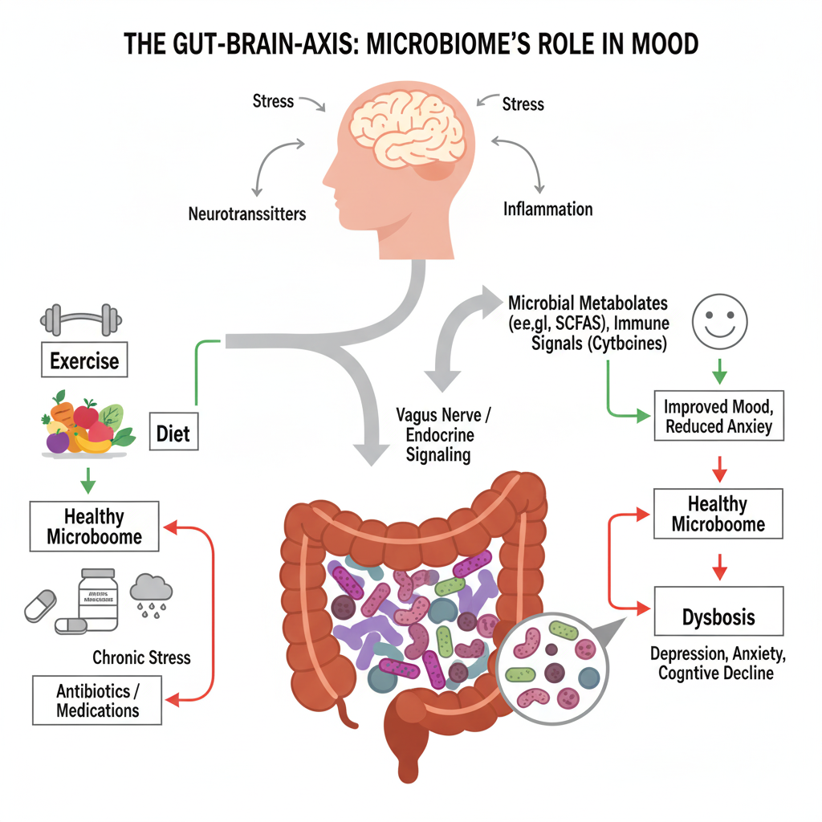
Figure 2 Gut-Brain axis mechanisms linking stress, dysbiosis, and mental health

3. GUT MICROBIOME AND ITS METABOLITES
3.1 Composition of the gut microbiome
The human gut microbiome is an intricate ecosystem of trillions of billions of bacteria, viruses, fungus and archaea. It is estimated that there are almost 1000 species of bacteria with extremely high diversity that varies so drastically between individuals due to food, age, genetics, and lifestyle [25]. More than 90% of the intestinal bacteria belong to two groups of bacteria: Firmicutes and Bacteroidetes, Actinobacteria and Proteobacteria, and Verrucomicrobia. The diversity of the microbial populations in the different segment of the gastrointestinal tract, from esophagus to the colon is highest in the colon [32]. Gut microbiota play an important role in digestive function, modulation of the immune system, protection against pathogenic invasion and production of metabolites. Diet changes and subsequent drug therapy may cause an alteration of the environment and an imbalance of certain microbes. This phenomenon of an imbalance of microbial composition referred to as dysbiosis, has been associated with numerous disorders ranging from local diseases like irritable bowel syndrome (IBS) affecting the gastrointestinal tract [33,34] to more systemic diseases such as cardiovascular disease, obesity and even autoimmune disorders [35]. Because the gut micro-biome has a major interaction with host health, the dominant micro-biome background and activities of gut micro-biota should be better characterized in definition of its function in systemic and ocular health.

3.2 Major Metabolites Produced by Gut Microbiota
Gut microbiota produces a tremendous range of metabolites that significantly affect both local as well as systemic health. These metabolites generally fall into several categories, including the SCFAs, BA, amino acids, and vitamins, and neurotransmitter [28]. Of these, the most studied are SCFA and BAs due to their systemic effects such as regulation of inflammation, immunity and metabolism. Dietary fibers are broken down in the gut microbiome to generate short-chain fatty acids (SCFAs) including acetate, propionate and butyrate. Fatty acids are required for intestinal homeostasis [29]. They supply energy to colonocytes, keep the intestinal barrier and regulate immunological function. Liver-generated bile acids are altered by gut microbiotas. Changed bile acids are associated with lipid digestion and cholesterol control. These metabolites impact systemic inflammation, metabolic pathways and brain function [30]. The microbiota-gut-brain axis regulates the ocular surface via metabolites produced by gut microbiota. This could therefore represent a connection between gastrointestinal disease and eye disease, including DED, at the level of regulating inflammatory response and immune regulation pathways.
3.2.1 Bile Acids
The metabolites made in the liver and altered by gut microbes are important – bile acids. [31]. They play a key role in digestion and absorption of lipids and fat-soluble vitamins. The functional diversity of gut microbiota is a key determinant of the modification of BA effects on metabolic health. BAs are able to interact with various receptors such as FXR and TGR5 and have a range of effects. Both FXR and TGR5 are known to modulate glucose and lipid metabolism and immune modulation, respectively. [36]. The altered composition and function of gut microbiota has been recently associated with several diseases including metabolic syndrome, obesity and IBD. Of significant note is that there is also some evidence showing that bile acids could be potentially protective of the ocular tissues by modulation of systemic inflammation and immune functions, which both have significant roles in the pathogenesis of ocular surface diseases like DED. Researchers suggest that bile acid signaling pathway may modify the inflammatory environments at the distant sites, such as in the eyes [37]. Additionally, FXR is activated by BA, and it has been shown that FXR regulates the production of pro-inflammatory cytokines and T-cell responses, which are involved in the pathogenesis of DED. Thus, in systemic inflammation, which may be due to dysbiosis, disruption of bile acid metabolism may play a role in aggravated ocular surface diseases. [38].
3.2.2 Short-Chain Fatty Acids (SCFAs)
The primary products of bacterial fermentation of dietary fibers are SCFAs. Butyrate is the most important SCFA as it has anti-inflammatory properties and protects the integrity of the gut epithelial barrier. It is produced by the Firmicutes and Bacteroidetes species in the colon as the main energy source for the colonocytes. [39]. It's been demonstrated to enhance tight junction integrity, sustaining the intestinal barrier and stopping gut permeability (Figure 2). In addition to its local action in the gut, butyrate has systemic effects which may affect other organs such as the eyes. Butyrate is thought to exert anti-inflammatory activity, in part by its ability to modulate the activity of immune cells, such as regulatory T-cells and macrophages, as well as by inhibiting the production of cytokines that are pro-inflammatory. This is done by interacting with GPR43 and GPR109A [40]. Because DED is inflammatory, butyrate's modulation of ocular surface inflammation potential is important. Butyrate and other SCFAs have been shown to promote Treg activity and Tregs play an essential role in immunological tolerance and inflammation control. They also proposed that it could be relevant for autoimmune diseases like DED where immunological dysregulation is the key component of the disease [41]. It is a fact that it impacts the gut microbiota – central nervous system communication pathway; it is now known to impact on the gut-brain axis.
3.3 Implications of the Gut Microbiome on Systemic and Ocular Health
Systemic inflammation due to dysbiosis has been hypothesized as a possible contributing cause in ocular surface diseases [42]. DED often leads to inflammation of the ocular surface as a result of a disruption of pro-inflammatory/anti-inflammatory signals which results in loss of epithelial integrity in the cornea and conjunctiva. Too much pro-inflammatory cytokines can then travel to the ocular surface through the systemic circulation, which may be increased by gut microbiome dysbiosis, aggravating this imbalance of inflammation. Hence the metabolites produced in the gut, such as SCFAs and bile acids, and the interactions thereof with immune cells would be important in controlling the severity of the inflammation of the ocular surface. [43,44]. Besides the direct influence of immunological regulation gut microbiome may also indirectly regulate the ocular homeostasis by way of other systemic disorders related to DED. Dysbiosis, a metabolic disorder of diabetes, is related to DED. Changes in the gut microbiota, which regulates glucose metabolism and insulin sensitivity, might worsen diabetic complications including dry eye syndrome [45]. DED is also common in inflammatory illnesses such rheumatoid arthritis and dysbiosis-causing Sjögren's syndrome.
4. EYE MICROBIOME
4.1 Composition and role of the ocular microbiome
An ocular microbiome is defined as a group of microorganisms found within the ocular surface or in other words on a conjunctiva, cornea, eyelids and the tear film [46]. Traditionally, it has been supposed that the ocular environment is sterile because ocular surface's immune defense mechanisms preclude microbial colonization. The discovery of rich and diverse microbial communities of the ocular surface by recent developments in microbiological and molecular techniques such as high-throughput 16S rRNA sequencing, however, have suggested that the ocular surface may not be as sterile as previously believed. [47]. Ocular microbiome is predominantly bacteria with small numbers of fungi and viruses, and even smaller numbers of archaea. There are also age, gender, genetic, geographical, dietary and environmental influences that impact the ocular microbiome and render it different for everyone. Firmicutes, Actinobacteria and Proteobacteria are the dominant bacterial phylum present in the ocular surface, with the former phylum containing the genera of Staphylococcus, Corynebacterium and Propionibacterium species. [48]. Other non-common species are Pseudomonas, Haemophilus, and Moraxella species. There are several important roles of the ocular microbiome in the maintenance of ocular health. Firstly it is a barrier to pathogenic microorganisms that are able to cause infection by out-competing pathogenic microbes for space and resources. Production of antimicrobial peptides, competition for resources, and control of local immune responses protect microbes. [33]. Surface immune system is regulated by ocular microbiota. Interaction with resident immune cells such as dendritic cells and macrophages is key in preserving the immunological homeostasis and tolerance. Microbiome directly affect the eye surface environment which protects, lubricates and nourishes the eye – the tear film. Because of its role in maintaining health, dysbiosis can induce inflammatory diseases of the eye in the ocular microbiome such as DED, bacterial keratitis and conjunctivitis. [49].
4.2 Inflammatory Diseases of the Ocular Surface
Ocular surface inflammatory diseases are a variety of diseases which cause an inflammatory response in the conjunctiva, cornea, and nearby ocular surfaces. Most common inflammatory diseases are DED, allergic conjunctivitis and blepharitis. [50]. These can cause vision problems, irritate the eye and in extreme cases, cause permanent damage to the surface of the eye. The pathogenesis of many of these diseases is probably multifactorial and involves environmental factors, genetic factors, genetic elements of the immune system or a combination of the above. Increasingly, however, there is evidence for both the ocular and the systemic microbiome components to regulate ocular surface inflammation [51]. DED is one of the most common inflammatory eye diseases associated with a decrease in tear film homeostasis, discomfort, dryness, and decreased ocular function. DED is an immunological reaction to environmental factors, including low humidity, screen time and air pollution, that causes inflammation of the ocular surface [52]. Recent studies suggest that dysbiosis of the ocular microbiome may play a role in the development and/or worsening of DED. In DED patients (Figure 3), there are greater disparities between the levels of Firmicutes and Proteobacteria on the ocular surface. Recent studies suggest that the ocular surface microbiome can be considered as a therapeutic and/or preventive target for multiple ocular diseases [53]. Application of topical Lactobacillus and Bifidobacterium may have an effect on the exogenous and local microbial balance while altering the immune response. The use of dietary therapies that improve gut and eye microbiome homeostasis with the use of omega-3 fatty acid, prebiotics and probiotics might be able to influence ocular surface diseases (OSDs) [53].

5. OBESITY, GUT MICROBIOTA DYSBIOSIS AND INFLUENCE ON OCULAR SURFACE HEALTH
Currently obesity is not just a metabolic disorder, it is also a heterogeneous systemic disorder and has a number of phenotypes including chronic low grade inflammation, oxidative stress, and microbiota dysbiosis. The microbial community in the gut of obese individuals (such as a lower diversity and higher Firmicutes/Bacteroidetes ratio) can influence metabolic pathways and systemic immune responses [54]. These dysbiotic changes have implications in the development of obesity-related complications early on in obesity disease development as well and may influence other distal organs, including the eye. There has been recent evidence suggesting the gut microbiota can exert immune effects and/or production of microbial metabolites (such as SCFAs and LPS) that affect the ocular surface homeostasis. It can enter the systemic circulation and impact the inflammatory pathway in the changing mechanism of dry eye disease and the resultant changes to the ocular surface inflammation [55]. Scrutineous eating patterns that are prevalent in obesity (Low Fiber, High Refined Carbohydrate, and High Saturated Fat) worsen the gut microbiota dysbiosis, not only by reducing the levels of protective microbial metabolites, but also by increasing systemic inflammation [56]. Lastly, obesity is also linked with insulin resistance and T2DM, (which have each been linked with MG disease and unstable tear film) [57]. Ocular surface homeostasis may be impaired by dysbiosis of the gut microbiome and metabolic disorders, which may work together. These collectively highlight the potential for investigating individual nutrition interventions and microbiome-targeting treatments to improve eye health in obesity. It can provide additional understanding of the gut-eye axis in obesity that can drive therapy individualization, as well as a more holistic strategy for the treatment of metabolic and ocular surface diseases.

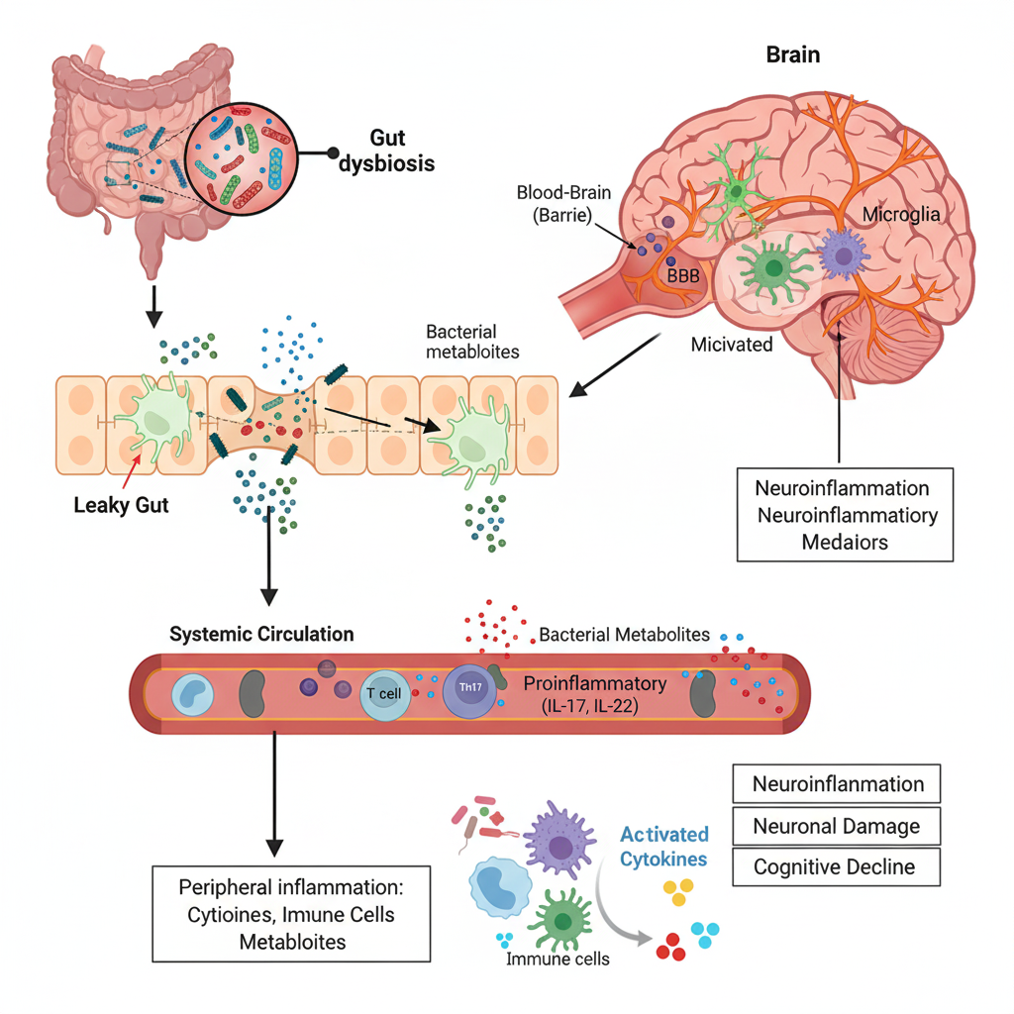
Figure 3 Schematic representation of gut dysbiosis–driven neuroinflammation

Table 2 Role of diet in shaping the composition of gut and ocular microbiota
Dietary Factor | Impact on Gut Microbiota | Impact on Ocular Microbiota | Reference
High-Fiber Diet Examples: whole grains, fruits, vegetables, legumes. | Promotes growth of beneficial Firmicutes, Bacteroidetes, and SCFAs (e.g., butyrate). | May improve immune regulation and reduce inflammation on the ocular surface. | [58]
High-Fat Diet Examples: red meat, processed foods, fried foods. | Increases Firmicutes to Bacteroidetes ratio, linked to dysbiosis. | Potentially increases ocular inflammation through gut-ocular axis. | [59]
Probiotic-Rich Diet Examples: yogurt, kefir, fermented vegetables. | Enhances gut microbial diversity, increases beneficial bacteria like Lactobacillus. | Supports ocular surface health, potentially modulating inflammation. | [60]
Polyphenol-Rich Diet Examples: berries, dark chocolate, green tea, nuts. | Increases beneficial microbes like Akkermansia, enhances SCFA production. | May influence ocular immunity by reducing oxidative stress. | [61]
Sugar- and Processed Food-Heavy Diet Examples: sugary snacks, sodas, refined carbs. | Leads to microbial imbalance, reducing microbial diversity and increasing pathogenic bacteria. | Can disrupt ocular microbiota, promoting dry eye symptoms and inflammation. | [62]

6. NUTRITION AND ITS IMPACT ON THE MICROBIOMES
6.1 Role of Diet in the Composition of Gut and Ocular Microbiota
Gut and ocular microbiomes composition and functions are influenced by nutrition. Diet is the crucial supply source for nutrients required by humans for good health, but diet is also the most important substrates needed for the growth and activities of the microbial community on ocular surface and gastrointestinal tract. The effects of the diet on the microbiome are mediated by certain components of the diet such as fibre, fat, protein, vitamins and minerals. [63]. These components modulate diversity and metabolic activity in the microorganisms and balance between various microorganisms in general-eubiosis. The changes in the body, due to dietary changes, also impact the ocular microbiome, as the shifts in the body may manifest in the form of the populations of microbes and their metabolism at the ocular surface, which will impact the health of the eye (Table 2). An ever-growing collection of evidence is emerging that demonstrates how a diet imbalance, whether due to overconsumption of processed foods, excess sugars or unhealthy fats, can lead to dysbiosis, or an imbalance of beneficial microbes and pathogenic microbes. [64]. Dysbiosis has been associated with the presence of numerous systemic diseases including obesity, metabolic disease, autoimmune disease and inflammatory disease like Dry Eye Disease (DED). This also relates to the connection between gut and ocular health. Gut microbial dysbiosis may affect distant organs, like the eyes, through changes in the immune system, inflammation and disease outcome. Thus, a balanced diet can be important in ensuring that there is gut health as well as ocular health. [65]. Systemic Immune responses are affected by diet which will influence the ocular microbiota. A healthy balance of bacteria on the eye surface can be maintained through a healthy balanced diet that includes adequate fiber intake and antioxidants and anti-inflammatory foods. The intake of fruits and vegetables and whole-grains supports the growth of lactobacilli and bifidobacteria that help control inflammation and the immune system. [66]. Conversely, high diets that include processed foods, sugars and trans fats promote pro-inflammatory bacteria, which may aggravate the disease, such as DED, and numerous other diseases associated with the ocular surface.

6.2 Nutrients Involved in Gut Microbial Eubiosis and Eye Health
External eye disease Nevertheless, maintenance of eubiosis, or balance of gut microbes is important for both gut health as well as systemic immune function including that to the eye. There are several nutrients that have direct or indirect effects on gut microbial eubiosis (which has an influence on GI health) and immune-mediated control of inflammation that may ultimately impact the ocular surface. [67]. All of these nutrient components are key to a healthy microbiome and supporting eye health: vitamins, minerals and polyunsaturated fatty acids. Microbial growth, immune function and therefore, overall health demand certain vitamins such as B1, B12 and A along with iron, selenium and calcium. The beneficial effects of a diet high in fruit and vegetables, lean proteins and sources of omega-3s on microbial diversity and inflammation are believed to have a beneficial impact in the gut and in the eye. [68].

6.2.1 Vitamins
Thiamine (B1) – Thiamine is essential for cell metabolism, particularly energy production. It could help to support levels of neurotransmitters and boost immunity [69]. Recent research also has shown that thiamine might be involved in the gut dysbiosis, intestinal permeability and inflammation. Ocular surface disease like DED can be worsened by an indirect systemic form of inflammation. Thiamine regulated energy metabolism of epithelial cells is key to maintaining health and function of the ocular surface [70]. B12 is needed for the production of red blood cells, DNA and neurological function. It can lead to anaemia, neuropathy and cognitive impairments. Butyrate-producing bacteria in the gut microbiome are regulated by Vitamin B12. [71]. Butyrate supports the integrity of the intestinal barrier and inflammation—both of which are factors that impact eye health. B12 deficiency can lead to an increase in bacteria that are harmful to the gut and are associated with inflammatory diseases, such as DED.
6.2.2 Iron
Iron is a crucial and essential nutrient for cellular metabolism, oxygen transport and immune function. Iron deficiency can cause anaemia and poor immune function. [72]. Iron is essential for the proliferation and metabolism of the gut microbiota and may result in disbalance of the gut microbiota in cases of iron availability changes. Both under and over-availability of iron may promote dysbiosis, leading to an increased population of pro-inflammatory bacteria, increased susceptibility to infections, and inflammatory conditions, like ocular surface diseases including DED. More recent research also showed that iron deficiency is connected with decreased levels of butyrate-producing bacteria, thus further worsening systemic inflammation and ocular health. [73].
6.2.3 Vitamin A
Vitamin A is important for the immune system and surface of the eyes. It secretes mucins that contribute to the stability of tear films and lubrication of the eye. Dry eyes and eye surface pathologies [74] are associated with vitamin A deficiency. Additionally, vitamin A has been shown to affect the gut microbiome through various mechanisms, such as encouraging the growth of beneficial bacteria and maintaining immune system function. It is especially relevant in the context of preventing the inflammation of the eye surface because of its role in the maintenance of mucosal immunity both in the gut and in the eyes.
6.2.4 Omega-3 Polyunsaturated Fatty Acids
Fatty fish and plant-based sources of omega-3 polyunsaturated fatty acids (PUFAs) have anti-inflammatory properties. EPA and DH in particular, are important for the gut microbiome and the ocular surface [75]. Furthermore, Omega-3 PUFAs positively promotes the growth of Bifidobacterium and Lactobacillus, and inhibits Firmicutes and Proteobacteria. The microbial signature consequently activates the immune system to respond and maintain the integrity of the gut to prevent distant inflammation. Omega 3 fatty acids reduce eyeball irritation. The benefit of these is for those with Dry Eye Disease (DED). Omega-3s boost resolvins and protectins and decrease pro-inflammatory cytokines. [76]. These effects are not only in the gut but also on the immune system and decrease eye inflammation. So by promoting the balance of the gut microbiota and by lowering inflammation, this supply of omega 3 by normal food intake or by supplementation can help to enhance gut and eye health.
6.2.5 Selenium
Selenium is an antioxidant trace mineral that is involved in cell resistance to oxidative stress and immune function. [77]. Probiotics that encourage good SCFA-producing bacteria and the regulation of inflammatory pathways have been reported as influencing the gut microbiome. Selenium can help reduce oxidative stress and inflammation, which can help protect the surfaces of the eyes, in some tests. The importance of selenium to gut and ocular health is illustrated by its connection with a number of inflammatory eye diseases including dry eye and thyroid orbitopathy.
6.2.6 Calcium
It plays a very important role in function of the bones, the muscles, and intracellular signaling. It is also considerably associated with immunomodulation. The interaction between Calc and gut microbiota is a mutual one: calcium "fosters" the activity of beneficial bacteria, such as lactobacilli (Lactobacillus spp. and Bifidobacterium spp), which plays a role in immune tolerance, with proflaminogenic effects. [78]. Ca is also directly able to affect the ocular surface by its direct actions on tear secretion, which is part of the homeostatic mechanisms of the ocular surface. Sufficient calcium intake has been demonstrated to halt the progression of DES, and will be primarily beneficial for those who have other systemic conditions that affect eye health such as rheumatoid arthritis. [79].

7. ASSOCIATION BETWEEN OCULAR HEALTH AND SYSTEMIC DISEASES

7.1 Link Between Gut Microbiota and Ocular Surface Diseases
Therefore, a gut-eye axis indicates that gut microbes may have a role in ocular health and gut dysbiosis may lead to ocular diseases. The gut microbiome is important in controlling immune responses, inflammation and systemic health, which in turn is essential for maintaining the homeostasis of the ocular surface. [80]. Stress, disease, diet and antibiotics can disrupt the gut flora, leading to systemic inflammation that can contribute to ocular disease such as Dry Eye Disease, conjunctivitis, thyroid orbitopathy, and uveitis. Intestinal microbiota changes are linked to several diseases of the ocular surface and play a role in the regulation of systemic and local immunity via the use of metabolites produced in the gut, including SCFAs and bile acids. Pathophysiology: Gut-derived inflammatory cytokines can enter the arterial blood sufficient to reach the ocular surface, bringing about activation of T lymphocytes, macrophages and cause ocular surface inflammation. Systemic immune response that supports pro-inflammatory modification of the immune cell population and drives ocular surface disease progression may also be affected by the intestinal permeability and dysbiosis [81]. Patients with autoimmune diseases, like rheumatoid arthritis and systemic lupus erythematosus, have ocular surface diseases, and dysbiosis has been linked to autoimmune diseases. Flares of disease are associated with increased levels of inflammatory cytokines such as TNF-α, IL-6 and IL-17 both in the gut and on the ocular surface. These cytokines are crucial in the pathophysiology of DED, resulting in tearing film instability, epithelial damage and conjunctiva and cornea inflammation [82].

7.2 Diabetes Mellitus and Ocular Surface Disorders
DM, specifically when it is poorly controlled, is one of the most common systemic diseases that leads to ocular surface disorders, such as DED. Numerous studies have recorded the relationship between DM and the ocular surface diseases. [83]. Patients suffering from diabetes have been documented to be at risk for developing DED and other complications, such as diabetic retinopathy and cataracts. It is hyperglycemia-induced changes in the ocular surface and systemic inflammation are multifactorial pathophysiology in diabetic patients. Chronic hyperglycemia is the sign of DM and is considered as the etiology of DED [84] due to the alteration in tear production, tear break-up time and tear film instability. Oxidative stress and activation of inflammatory pathways are the direct effects of high glucose on the epithelial surface of the eye leading to disruption of the corneal and conjunctival epithelium. Hyperglycaemia also affects the meibomian glands, a function that can be lost, worsening the symptoms of dry eye.
7.3 The link between gut microbiota and diabetes
Recent research identified the gut microbiome as being able to modulate metabolic and immune responses, making it a link to the development and progression of diabetes and complications of diabetes. [85-89]. In diabetes, there was a change in the gut microbiome with a reduction in the diversity of microbial communities and pro-inflammatory bacteria becoming overgrown. This dysbiosis can cause inflammation throughout the body that may contribute to the inflammatory process observed in ocular surface diseases such as DED. Gut microbes could stimulate pro-inflammatory cytokines that damage the epithelium and block the production of tears. Healthy gut bacteria create anti-inflammatory SCFAs during the process of dietary fiber fermentation. Systemic inflammation and ocular surface irritation in diabetic patients are due to gut dysbiosis, which results in the loss of SCFAs. Systemic inflammation can be modulated by diet or probiotic supplementation which may be able to affect the ocular changes associated with diabetes such as DED.

7.4 Role of Gut Microbiota in Disease Development
7.4.1 Thyroid Orbitopathy (TO)
Thyroid orbitopathy, also known as Graves' orbitopathy or thyroid-associated ophthalmopathy (TAO), is an autoimmune disease that involves the orbit and the ocular tissues, resulting in inflammation and swelling. At worst, it can cause the eyeball to protrude and loss of sight [90]. TO is usually associated with hyperthyroid patients, but can also occur with hypothyroid and euthyroid patients. TO triggers inflammation and swelling of extraocular muscles and retino-orbital tissues as a result of inflammation of the immune system and auto-immunity against orbital fibroblasts and retino-orbital tissues. Recent studies indicate that gut microbiota could be a key player in the development and progression of TO [91]. The gut microbiome-immune system interaction is critical to autoimmune diseases and patients with thyroid disease have dysbiosis. The imbalance in the gut microbiota could alter the immune response and trigger the activation of auto-reactive T lymphocytes against orbital tissue in thyroid orbitopathy.
7.4.2 Gut Microbiota and Autoimmunity
Gut dysbiosis will activate inflammatory cascades and immune cells that will result in autoimmune disorders [92]. The metabolites produced by the gut microbiota, such as SCFAs and bile acids, could impact the development of T helper and regulatory T cells, both of which play a role in autoimmune diseases. Short chain fatty acid (SCFAs) including butyrate affect the phenotype and immunological tolerance of T cells and could be involved in the development of autoimmune disease. Such a change in gut microbiome increases gut permeability, further increases systemic inflammation, and permits the autoreactive immune T-cells in the gut to access the ocular tissues. [93].
7.5 Gut-Thyroid Connection
Gut health influences production of the thyroid hormones and thus, there is an impact of gut-derived metabolites and microbiota on the thyroid gland. Growing body of evidence indicating a relationship between gut microbes and thyroid function. Mechanisms wherein gut microbiota could interfere with thyroid function have also been proposed, mainly related to pathways in the metabolism of iodine, a key precursor for the synthesis of thyroid hormone. The relationship between the intestinal state and the activities of the thyroid could be a factor that predisposes to the onset of sickness. Thyroid autoimmunity may worsen the disease by the proinflammatory mediators that might be produced in the gut [94]. The role of gut microbiome in thyroid orbitopathy is thus an area of active research. Diet or probiotics may modify gut microbiota, which in turn could impact inflammation and immune activation as a hallmark of the disease pathogenesis of thyroid orbitopathy and provide novel therapeutic avenues for this debilitating disease [95].

8. DIETARY INTERVENTION AND MANAGEMENT OF DRY EYE DISEASE (DED)
8.1 Effect of Diet on Dry Eye Syndrome
A healthy diet is essential for a healthy body and a fascinating article on more studies has indicated that diet can also affect development and treatment of eye diseases like Dry Eye Disease. Systemic inflammation, oxidative stress and metabolic pathway modifications caused by diet easily influence the tear film and ocular surface [96]. Recent research suggests that inflammatory foods or foods that alter gut microbiota can worsen DED, and anti-inflammatory foods and eye health promoting nutrients could be beneficial. If following a Western diet plan, a diet rich in processed foods, sugars and omega-6 fatty acids may increase pro-inflammatory cytokines. Such immunity-inducing diet can lead to exacerbation of chronic systemic inflammatory diseases like DED [97]. Anti-inflammatory diets (such as omega-3 fatty acid, antioxidants and fiber) have been shown to have a beneficial effect on the ocular surface and DED symptoms, in contrast. Omega-3 fatty acids are known to be anti-inflammatory, and the association of diet and DED is related to it. EPA and DHA are the two primary types of omega-3s [98]. They regulate pro-inflammatory cytokines, make up the tear film and mybomian gland to keep the lipid layer intact. Clinical studies are however, still reviewed in a number of literatures which demonstrate enhanced tear production, ocular surface integrity and improvement in dry eye symptoms following oral administration of omega-3 fatty acids. To minimize oxidative damage, the main contributor to DED, antioxidant supplementations such as vitamins A, C, and E are used [99]. These antioxidants help to protect the surface of the eye from the damage caused by free radicals on the function of the epithelial cells and infiltration of inflammatory cells. Therefore, antioxidant foods such as leafy green vegetables, citrus fruits and berries are essential to the health-care of the eyes and could help slow the progression of DED. Further, the intake of fibre has systemic effects, such as anti-inflammatory effects and an increase in the production of anti-inflammatory metabolites such as SCFAs. Whole grain, vegetable and fruit fiber could provide systemic anti-inflammatory effects and improvements in gut microbiota and ocular surface.

8.2 Management strategy for DED
8.2.1 Dietary interventions
With growing understanding of the relationship between gut and eye health, dietary intervention is an intriguing way to manage DED. Diet alteration can be used to enhance anti-inflammatory pathways, support balance of gut microbiota, and increase tear film production as complementary or even alternative treatment approaches to conventional pharmacological therapies for DED.
8.2.2 Omega-3 Fatty Acids and Their Role in the Management of DED
Omega-3 fatty acids are the most researched of the many diet therapies used to treat DED. Omega-3s may help to reduce production of inflammatory cytokines that are critical to the pathogenesis of DED. Oral omega-3 fatty acid supplementation has been shown in clinical studies to improve tear production, tear film stability and decrease symptoms of dry eye. [100]. Omega-3s can also impact the ocular surface, through the ability to stimulate the meibomian glands to produce the oily layer of the tear film and stop it from evaporating. Omega-3 may help maintain the lipid layer of the tear film which helps to prevent the lipids from evaporating and can help relieve symptoms of meibomian gland dysfunction (MGD), the most common cause of evaporative dry eye.
8.2.3 Probiotics and Gut Microbiota
With heightened awareness of the importance of the gut microbiome in systemic inflammation and immune regulation, an interest in probiotics to repopulate a healthy gut microbiome as a treatment for DED has emerged [101]. Probiotics, Lactobacillus spp and Bifidobacterium spp were demonstrated to positively impact gut barrier function, reduce intestinal permeability and boost production of anti-inflammatory SCFAs like butyrate. The beneficial bacteria can also help decrease systemic inflammation and ultimately ocular surface inflammation [102]. In addition, the gut-eye axis has been increasingly documented to be a possible actual therapeutic target in the management of DED. Consequently, probiotic supplementation could potentially restore an eye's health, by enhancing the immune system's balance and minimizing inflammation on the surface of the eye.
8.2.4 Vitamins and Minerals for Ocular Health
Some vitamins and minerals are essential to good eye health. A strong antioxidant, vitamin A, preserves the corneal epithelium from keratinization, a common feature of DED. [103]. Vitamin A deficiency can cause a severe dry eye effect; taking supplements can alleviate these symptoms. Vitamins B12 have been reported to play a role in maintaining the health of corneal epithelial layers, and they might have anti-inflammatory effects on the ocular surface. Iron is involved in intracellular functions and has recently been implicated with the antioxidant function of oxidant-inflammatory processes. Its deficiency will likely increase the oxidative harm to the ocular surface, thereby making DED worse. [104]. When consumed in adequate amounts these vitamins and minerals will have beneficial effects in prevention and treatment of DED. Apart from the role of individual nutrients, selenium and calcium have been researched for their roles in the inflammatory pathways. Selenium is an antioxidant that decreases oxidative stress in the body. Multiple immune cell functions are influenced by calcium [105,106]. Deficiencies of these minerals have been correlated with increased inflammation and ocular surface damage, thus placing a lot of emphasis on a balanced diet in the management of DED.

9. GUT MICROBIOTA'S ROLE IN DRUG METABOLISM
The gut microbiota has been recognized more and more as a key factor involved in this process and in drug efficacy. The trillions of gut microbes produce various enzymes which can modify the molecular structure of drugs. The microbial enzymes could further activate or inactivate the drugs and also be toxic to them, which could in turn have a profound impact on their bioavailability and efficacy. This is because the gut microbiota is critical to the therapeutic effect of the drug, sulfasalazine, which is metabolized to active metabolites (5-aminosalicylic acid and sulfapyridine) by intestinal bacteria during treatment of inflammatory bowel diseases. The gastrointestinal (GI) tract is one example of the role it plays in the whole-body pharmacokinetics and pharmacodynamics of drugs. Besides using its enzymatic functions, gut microbiota also have the ability to alter the pharmacokinetics of drugs through the effects on ADME. The gut bacteria produce short chain fatty acids (SCFAs) which are spread out and act on the host cells. This interaction has been demonstrated to affect drug transporters and metabolic enzymes. Such that for example, SCFAs modulate the expression of cytochrome P450 enzymes, which are highly important in drug metabolism in the liver. Such interactions may influence clearing of the drug and thus cause personal differences in drug response or drug toxicity in people whose gut microbiota composition is different. Additionally, drug metabolism is affected by the special function played by the microbiome, which is further complicated by gut dysbiosis, a disruption of microbial populations. Dysbiosis may impact production of important metabolites which mitigate pathways of drug metabolism and otherwise affect systemic inflammatory changes. These inflammatory disease contexts in which the microbiome composition is associated with disease severity and outcome can manifest as altered drug response. The understanding of the effects of dysbiosis on drug metabolism may pave the way for new therapies involving targeted microbiome modulation with pro- and prebiotics to increase the efficacy of drug treatment and decrease adverse effects. Another major group of metabolites produced and modified by gut microbes that are altered in dysbiosis are bile acids. Primary bile acids secreted in the intestine are rapidly metabolized to secondary bile acids by gut bacteria, which are able to regulate systemic metabolic pathways and drug response via nuclear receptors such as FXR and TGR5. These changes in bile-acid profiles associated with gut dysbiosis have been associated with diabetes and inflammatory bowel disease and underline the importance of gut microbial homeostasis for optimal drug metabolism and response to therapy. These molecular findings on unregulated mechanisms of gut-microbe drug modification, at a minimum, gives the potential for a mechanism-based intervention approach, via which doctors could customize or transform drugs. From microbiome profiling to inform drug response to microbiome-directed therapy to alter drug metabolism, these are a few examples of such strategies that may become cornerstones for achieving successful breakthroughs in the treatment of an entire repertoire of diseases. This new field of study thus underscores the intricate interactions between gut microbiota and whole body homeostasis and indicates a promising avenue for drug development, as well as clinical application.

10. FUTURE PROSPECTS
It is the interaction of gut microbiota that is of potential interest for future research insights and therapeutic applications with respect to ocular health. The Gut-Ocular Surface Axis is a crucial topic that needs to be further developed. Recent studies have revealed the effects of metabolites produced in the gut on eye health. But unlike other organ systems, the molecular mechanisms through which such metabolites affect the ocular surface are not well established. Further investigations of the pathway mechanisms of these inhibitory effects may result in more effective therapeutic applications in DED [107]. The third area is creating a customized nutrition program. The diversity of the gut microbiota composition indicates that a targeted dietary therapy will have a greater beneficial effect in the prognosis of eye surface diseases. Identifying individual nutrients, and how these may interact with the gut microbiota, needs to be further investigated to individualise nutritional protocols to prevent and treat DED [108]. Moreover, clinical research enables us to comprehend the impact of food supplements on eye health. The long-term safety and efficacy of these omega-3 fatty acids, probiotics and critical vitamins should be assessed in these studies. The optimum dosage, formulation and treatment periods of these therapies need to be established to achieve the maximum therapeutic benefit for DED subtype patients. [109]. Probiotics and prebiotics can modulate the microbiota and provide treatment of DED without invasion. Further research is needed to discover how such treatments affect systemic and ocular inflammation. Such treatments may modulate gut health to change immune responses and minimize eye-related chronic inflammation. While diet may help regulate DED, further research is required to identify diets which will impact on eye health and to identify the most appropriate nutritional therapies. The Gut-Ocular Surface Axis needs to be established. Much has been learnt about gut microbiota and distant systemic diseases, but the molecular mechanisms underlying such changes in the gut and the impact on the eye remains to be investigated. To formulate a specific dietary strategy for DED, it is necessary to understand how specific gut-borne compounds may enter the eye and affect intraocular environment in ways that decrease inflammation and promote epithelial function. Long-term clinical trials must be conducted on omega-3s, probiotics and other nutrient supplements to prevent and treat DED. These supplements should be of the appropriate duration, quantity and format for DED individuals with varied subtypes, and should be based on clinical research.

11. Conclusion
The gut–ocular axis may offer new clues to the mechanisms involved in the pathophysiology of DED and other diseases of the ocular surface. The present review based on the potential systemic and ocular inflammatory modulatory effects of gut-derived SCFAs and bile acids. This increasing body of evidence corroborates the need for gut microbial eubiosis maintenance by nutritional approaches protective for the ocular surface eubiosis and ocular health. Moreover, this study on the gut-eye axis provides potential therapeutic implications for the treatment of DED in the framework of dietary and probiotic interventions as add-on or alternative therapy. It discusses the importance of nutrients to achieve a healthy balance of the gut and eye microbiome and the potential of nutrients as a strategy to help lower inflammation and restore eye surface health. But those results are qualified with the note that more research is needed. Further studies should be directed towards understanding the exact molecular mechanisms and connecting gut health with eye health function as well as dietary interventions supported by scientific evidence for regulating eye diseases. And as our current interpretation of these complex interactions continues to improve, so do the opportunities for individualized therapies, and in turn, will help direct how we affect outcomes and quality of life in our patients.

Declaration
The authors declared no conflict of interest.

Consent
NA.
Ethical Statement
NA.
Funding
We did not have any funding source for this work and none of the authors have any kind of conflict of interests.
Authors Contributions
AB and SS participated in the conception and design of the study. AB, SS, GP, ABB, VS, and NK participated in the literature search and data extraction. KS, SSP, SS, SC, and AKS contributed to drafting and writing the manuscript. RKC and RM critically reviewed, revised, and finalized the article. All authors read and approved the final manuscript.

References
- Deo, N. & Nagrale, P. (2024) ‘Dry Eye Disease: An Overview of Its Risk Factors, Diagnosis, and Prevalence by Age, Sex, and Race’, Cureus, 16(2), p. e54028.
- Parrado, C., Llabrés, M., Gonzalo, R., Serra, L. & Cordero, M. (2019) ‘Environmental stressors on skin aging. Mechanistic insights’, Frontiers in Pharmacology, 10, p. 759.
- Parua, S., Choudhury, G.R., Bhattacharya, S., Hazra, A., Dutta, S., Sengupta, P. & Bhattacharya, K. (2024) ‘Melatonin in Female Fertility: Multifaceted Role From Reproductive Physiology to Therapeutic Potential in Polycystic Ovary Syndrome, Endometriosis, and Ovarian Failure’, Chronobiology in Medicine, 6(4), pp. 145–162.
- Peck, T., Olsakovsky, L. & Aggarwal, S. (2017) ‘Dry eye syndrome in menopause and perimenopausal age group’, Journal of Midlife Health, 8(2), pp. 51–54.
- Zhang, X., Mobeen, R., Durr, N.J. & Elshout, P.J. (2017) ‘Dry eye management: targeting the ocular surface microenvironment’, International Journal of Molecular Sciences, 18(7), p. 1398.
- Napolitano, P., De Rosa, N., Cennamo, M., (2021) ‘Influence of gut microbiota on eye diseases: An overview’, Annals of Medicine, 53(1), pp. 750–761.
- Zysset-Burri, D.C., Morandi, E., Herzog, S.A., (2023) ‘The role of the gut microbiome in eye diseases’, Progress in Retinal and Eye Research, 92, p. 101117.
- Tîrziu, A.T., Călărașu, A., Cernescu, I., (2024) ‘From gut to eye: Exploring the role of microbiome imbalance in ocular diseases’, Journal of Clinical Medicine, 13(18), p. 5611.
- Zhao, Y., Qiu, P. & Shen, T. (2024) ‘Gut microbiota and eye diseases: A review’, Medicine (Baltimore), 103(39), p. e39866.
- Findlay, Q. & Reid, K. (2018) ‘Dry eye disease: when to treat and when to refer’, Australian Prescriber, 41(5), pp. 160–163.
- Wang, J., Zhu, N., Su, X., Gao, Y. & Yang, R. (2023) ‘Gut-microbiota-derived metabolites maintain gut and systemic immune homeostasis’, Cells, 12(5), p. 793.
- Sun, L. & Ye, R.D. (2012) ‘Role of G protein-coupled receptors in inflammation’, Acta Pharmacologica Sinica, 33(3), pp. 342–350.
- Bhattacharya, K., Bhattacharya, S., (2021) ‘Coronavirus Disease 2019 (COVID-19) and Pregnancy’, Biomedical Pharmacology Journal, 14(3). Available at: https://dx.doi.org/10.13005/bpj/2219.
- Dey, R., Bhattacharya, K., Basak, A.K., (2023) ‘Inflammatory perspectives of polycystic ovary syndrome: role of specific mediators and markers’, Middle East Fertility Society Journal, 28, p. 33.
- Bhattacharya, K., Bhattacharya, S., (2021) ‘SARS-CoV-2 infection and human semen: possible modes of contamination and transmission’, Middle East Fertility Society Journal, 26(1), p. 18. Available at: https://doi.org/10.1186/s43043-021-00063-6.
- Kulshrestha, R., (2020) ‘Periodontitis as an Independent Factor in Pathogenesis of Erectile Dysfunction’, Biomedical Pharmacology Journal, 13(1). Available at: https://dx.doi.org/10.13005/bpj/1852.
- Peng, L., Li, Z.R., Greenberg, J.Z., (2009) ‘Butyrate enhances the intestinal barrier by facilitating tight junction assembly via activation of AMP-activated protein kinase in Caco-2 cell monolayers’, Journal of Nutrition, 139(9), pp. 1619–1625.
- Brown, E.M., Clardy, J. & Xavier, R.J. (2023) ‘Gut microbiome lipid metabolism and its impact on host physiology’, Cell Host & Microbe, 31(2), pp. 173–186.
- Calzadilla, N., (2022) ‘Bile acids as inflammatory mediators and modulators of intestinal permeability’, Frontiers in Immunology, 13, p. 1021924.
- Bertolini, A., Fiorotto, R. & Strazzabosco, M. (2022) ‘Bile acids and their receptors: modulators and therapeutic targets in liver inflammation’, Seminars in Immunopathology, 44(4), pp. 547–564.
- De Paiva, C.S., Chotikavanich, S., Pangelinan, S.B., Pitcher, J.D. III, Fang, B., Zheng, X., Ma, P., Farley, W.J., Siemasko, K.F., Niederkorn, J.Y., Stern, M.E., Li, D.Q. & Pflugfelder, S.C. (2009) ‘IL-17 disrupts corneal barrier following desiccating stress’, Mucosal Immunology, 2(3), pp. 243–253.
- Song, W., Yue, Y. & Zhang, Q. (2023) ‘Imbalance of gut microbiota is involved in the development of chronic obstructive pulmonary disease: A review’, Biomedicine & Pharmacotherapy, 165, p. 115150.
- Rao, S.K., Mohan, R., Gokhale, N., Matalia, H. & Mehta, P. (2022) ‘Inflammation and dry eye disease—where are we?’, International Journal of Ophthalmology, 15(5), pp. 820–827.
- Belkaid, Y. & Hand, T.W. (2014) ‘Role of the microbiota in immunity and inflammation’, Cell, 157(1), pp. 121–141.
- Li, M., Li, M., Dai, Y., Li, D., Yu, H., Liu, J., Gao, H., Zhong, Y., Huang, M., Lin, J., Xie, Y., Guo, Z. & Chen, X. (2023) ‘16S rRNA gene sequencing reveals the correlation between the gut microbiota and the susceptibility to pathological scars’, Frontiers in Microbiology, 14, p. 1215884.
- Tavakoli, A., Markoulli, M., Papas, E. & Flanagan, J. (2022) ‘The impact of probiotics and prebiotics on dry eye disease signs and symptoms’, Journal of Clinical Medicine, 11(16), p. 4889.
- Zhang, Z., Zou, X., Xue, W., Zhang, P., Wang, S. & Zou, H. (2021) ‘Ocular surface microbiota in diabetic patients with dry eye disease’, Investigative Ophthalmology & Visual Science, 62(12), p. 13.
- Chen, J. & Vitetta, L. (2021) ‘Modulation of Gut Microbiota for the Prevention and Treatment of COVID-19’, Journal of Clinical Medicine, 10(13), p. 2903.
- Yoo, J.Y., Groer, M., Ozorio Dutra, S.V., Sarkar, A. & McSkimming, D.I. (2020) ‘Gut microbiota and immune system interactions’, Microorganisms, 8(10), p. 1587.
- Wallen, Z.D., Demirkan, A., Twa, G., Cohen, G., Dean, M.N., Standaert, D.G., Sampson, T.R. & Payami, H. (2022) ‘Metagenomics of Parkinson’s disease implicates the gut microbiome in multiple disease mechanisms’, Nature Communications, 13(1), p. 6958.
- Yun, S.W., Son, Y.H., Lee, D.Y., Shin, Y.J., Han, M.J. & Kim, D.H. (2021) ‘Lactobacillus plantarum and Bifidobacterium bifidum alleviate dry eye in mice with exorbital lacrimal gland excision by modulating gut inflammation and microbiota’, Food & Function, 12(6), pp. 2489–2497.
- Tavakoli, A. & Flanagan, J.L. (2019) ‘The case for a more holistic approach to dry eye disease: Is it time to move beyond antibiotics?’, Antibiotics (Basel), 8(3), p. 88.
- Zhang, Q.Y., Yan, Z.B., Meng, Y.M., Hong, X.Y., Shao, G., Ma, J.J., Cheng, X.R., Liu, J., Kang, J. & Fu, C.Y. (2021) ‘Antimicrobial peptides: mechanism of action, activity and clinical potential’, Military Medical Research, 8(1), p. 48.
- Parua, S., Das, A., Hazra, A., Chaudhuri, P., Bhattacharya, K., Dutta, S. & Sengupta, P. (2025) ‘Assessing body composition through anthropometry: Implications for diagnosing and managing polycystic ovary syndrome (PCOS)’, Clinical Physiology and Functional Imaging, 45(1), e12905.
- Bose, C., Syamal, A.K. & Bhattacharya, K. (2022) ‘Pattern of dietary intake and physical activity among obese adults in rural vs urban areas in West Bengal: A cross-sectional study’, Research Journal of Pharmacy and Technology, 15(9), pp. 3924–3930.
- Chiang, J.Y.L. & Ferrell, J.M. (2020) ‘Bile acid receptors FXR and TGR5 signaling in fatty liver diseases and therapy’, American Journal of Physiology-Gastrointestinal and Liver Physiology, 318(3), pp. G554–G573.
- Li, M., Cai, S.Y. & Boyer, J.L. (2017) ‘Mechanisms of bile acid mediated inflammation in the liver’, Molecular Aspects of Medicine, 56, pp. 45–53.
- Campagnoli, L.I.M., Varesi, A., Barbieri, A., Marchesi, N. & Pascale, A. (2023) ‘Targeting the Gut-Eye Axis: An Emerging Strategy to Face Ocular Diseases’, International Journal of Molecular Sciences, 24(17), p. 13338.
- Shin, Y., Han, S., Kwon, J., Ju, S., Choi, T.G., Kang, I. & Kim, S.S. (2023) ‘Roles of short-chain fatty acids in inflammatory bowel disease’, Nutrients, 15(20), p. 4466.
- Sivaprakasam, S., Prasad, P.D. & Singh, N. (2016) ‘Benefits of short-chain fatty acids and their receptors in inflammation and carcinogenesis’, Pharmacology & Therapeutics, 164, pp. 144–151.
- Pisetsky, D.S. (2023) ‘Pathogenesis of autoimmune disease’, Nature Reviews Nephrology, 19(8), pp. 509–524.
- Wang, C., Bian, F., Li, Z., Zhang, Y., Li, X., Ma, J., Li, Y. & Pflugfelder, S.C. (2019) ‘Dysbiosis modulates ocular surface inflammatory response to lipopolysaccharide’, Investigative Ophthalmology & Visual Science, 60(13), pp. 4224–4233.
- Fogelson, K.A., Dorrestein, P.C. & Zarrinpar, A. (2023) ‘The Gut Microbial Bile Acid Modulation and Its Relevance to Digestive Health and Diseases’, Gastroenterology, 164(7), pp. 1069–1085.
- Adhikary, K., Mohanty, S., Bandyopadhyay, B., Maiti, R., Bhattacharya, K. & Karak, P. (2024) ‘β-Amyloid peptide modulates peripheral immune responses and neuroinflammation in rats’, Biomolecular Concepts, 15(1). doi: 10.1515/bmc-2022-0042.
- Iatcu, C.O., Steen, A. & Covasa, M. (2021) ‘Gut microbiota and complications of type-2 diabetes’, Nutrients, 14(1), p. 166.
- Peter, V.G., D'Souza, S., D'Souza, S., et al. (2023) ‘Investigating the ocular surface microbiome: What can it tell us?’, Clinical Ophthalmology, 17, pp. 259–271.
- Chowdhary, A., Van Gelder, R.N. & Sundararajan, M. (2023) ‘Methodologic Considerations for Studying the Ocular Surface Microbiome’, Ophthalmology Science, 3(4), p. 100408.
- Petrillo, F., Pignatelli, F., Cammalleri, V., et al. (2020) ‘Current evidence on the ocular surface microbiota and related diseases’, Microorganisms, 8(7), p. 1033.
- Xue, W., Li, J.J., Zou, Y., Zou, B. & Wei, L. (2021) ‘Microbiota and ocular diseases’, Frontiers in Cellular and Infection Microbiology, 11, p. 759333.
- Hom, M.M., Nguyen, A.L. & Bielory, L. (2012) ‘Allergic conjunctivitis and dry eye syndrome’, Annals of Allergy, Asthma & Immunology, 108(3), pp. 163–166.
- Li, J.J., Yi, S. & Wei, L. (2020) ‘Ocular microbiota and intraocular inflammation’, Frontiers in Immunology, 11, p. 609765.
- Sheppard, J., Shen Lee, B. & Periman, L.M. (2023) ‘Dry eye disease: Identification and therapeutic strategies for primary care clinicians and clinical specialists’, Annals of Medicine, 55(1), pp. 241–252.
- Gomes, J.A.P., Frizon, L. & Demeda, V.F. (2020) ‘Ocular Surface Microbiome in Health and Disease’, Asia-Pacific Journal of Ophthalmology, 9(6), pp. 505–511.
- Macedo-Lozano, S.D., Garcia-Aguilar, M.A., Salinas-Sedo, G., Cardoza-Jiménez, K., Yang, W. & Zheng, M.H. (2025) ‘Association between hypothyroidism and metabolic dysfunction-associated steatohepatitis in adults with obesity without diabetes’, Obesity Medicine, 55, p. 100604.
- Cap, D.M., Dong, K.T., Nguyen, D.T.H., Nguyen, H.T., Tang, K.X. & Cao, A.H. (2025) ‘Assessing the relationship between demographic characteristics, lifestyle factors, and obesity metrics among adults in Haiphong, Vietnam’, Obesity Medicine, 55, p. 100600.
- Oladipupo, S.O., Ezenabor, E.H., Ojo, A.B., Ogunlakin, A.D. & Ojo, O.A. (2025) ‘Interplay of the pathophysiological mechanisms of non-alcoholic fatty liver disease, diabetes mellitus, and inflammation: A growing threat to public health’, Obesity Medicine, 55, p. 100613.
- Panjawatanan, P. & Comi, R.J. (2025) ‘GLP-1 agonists in Type 1 diabetes – Indications and use’, Obesity Medicine, 54, p. 100591.
- Dreher, M.L. (2018) ‘Whole Fruits and Fruit Fiber Emerging Health Effects’, Nutrients, 10(12), p. 1833.
- Djuric, Z. (2023) ‘Dietary approaches for normalizing dysbiosis induced by high-fat, obesogenic diets’, Current Opinion in Clinical Nutrition and Metabolic Care, 26(3), pp. 293–301.
- Leeuwendaal, N.K., Stanton, C., O'Toole, P.W. & Beresford, T.P. (2022) ‘Fermented foods, health and the gut microbiome’, Nutrients, 14(7), p. 1527.
- Jawhara, S. (2024) ‘How do polyphenol-rich foods prevent oxidative stress and maintain gut health?’, Microorganisms, 12(8), p. 1570.
- Fajstova, A., Horak, J., Lichnovska, A., et al. (2020) ‘Diet Rich in Simple Sugars Promotes Pro-Inflammatory Response via Gut Microbiota Alteration and TLR4 Signaling’, Cells, 9(12), p. 2701.
- Vijay, A., Astbury, S., Le Roy, C., Spector, T.D. & Valdes, A.M. (2021) ‘The prebiotic effects of omega-3 fatty acid supplementation: A six-week randomised intervention trial’, Gut Microbes, 13(1), pp. 1–11.
- Kang, G.G., Trevaskis, N.L., Murphy, A.J. & Febbraio, M.A. (2022) ‘Diet-induced gut dysbiosis and inflammation: Key drivers of obesity-driven NASH’, iScience, 26(1), p. 105905.
- Aziz, T., Hussain, N., Hameed, Z. & Lin, L. (2024) ‘Elucidating the role of diet in maintaining gut health to reduce the risk of obesity, cardiovascular and other age-related inflammatory diseases: recent challenges and future recommendations’, Gut Microbes, 16(1), p. 2297864.
- Rinninella, E., Cintoni, M., Raoul, P., Gasbarrini, A. & Mele, M.C. (2023) ‘The role of diet in shaping human gut microbiota’, Best Practice & Research Clinical Gastroenterology, 62–63, p. 101828.
- Zhang, P. (2022) ‘Influence of foods and nutrition on the gut microbiome and implications for intestinal health’, International Journal of Molecular Sciences, 23(17), p. 9588.
- Noriega, B.S., Sanchez-Gonzalez, M.A., Salyakina, D. & Coffman, J. (2016) ‘Understanding the impact of omega-3 rich diet on the gut microbiota’, Case Reports in Medicine, 2016, p. 3089303.
- Channer, B., Matt, S.M., Nick, J., Zohar, Y., Ben-Haim, M., Magen, E., et al. (2023) ‘Dopamine, Immunity, and Disease’, Pharmacological Reviews, 75(1), pp. 62–158.
- Subramanian, V.S., Mohammed, Z.M., Molina, A., Marchant, J.S., Vaziri, N.D. & Said, H.M. (2007) ‘Vitamin B1 (thiamine) uptake by human retinal pigment epithelial (ARPE-19) cells: mechanism and regulation’, Journal of Physiology, 582(Pt 1), pp. 73–85.
- Guetterman, H.M., Vázquez-Lorente, H., van der Merwe, L.F., et al. (2022) ‘Vitamin B-12 and the Gastrointestinal Microbiome: A Systematic Review’, Advances in Nutrition, 13(2), pp. 530–558.
- Cherayil, B.J. (2010) ‘Iron and immunity: immunological consequences of iron deficiency and overload’, Archives of Immunology and Therapy Experimental, 58(6), pp. 407–415.
- Malesza, I.J., Bartoszewicz, M., Bąk, K., et al. (2022) ‘The dark side of iron: The relationship between iron, inflammation and gut microbiota in selected diseases associated with iron deficiency anaemia—a narrative review’, Nutrients, 14(17), p. 3478.
- Gilbert, C. (2013) ‘The eye signs of vitamin A deficiency’, Community Eye Health, 26(84), pp. 66–67.
- Xu, H., et al. (2022) ‘Plasma levels of omega-3 and omega-6 derived oxylipins are associated with fecal microbiota composition in young adults’, Nutrients, 14(23), p. 4991.
- Calder, P.C. (2017) ‘Omega-3 fatty acids and inflammatory processes: from molecules to man’, Biochemical Society Transactions, 45(5), pp. 1105–1115.
- Zhang, F., Li, X. & Wei, Y. (2023) ‘Selenium and selenoproteins in health’, Biomolecules, 13(5), p. 799.
- Wang, J., Wu, S., Zhang, Y., Yang, J. & Hu, Z. (2022) ‘Gut microbiota and calcium balance’, Frontiers in Microbiology, 13, p. 1033933.
- Castro-Castaneda, C.R., et al. (2022) ‘Nutraceuticals: A Promising Therapeutic Approach in Ophthalmology’, Nutrients, 14(23), p. 5014.
- Amin, H. & Shoughy, S. (2023) ‘The role of microbiome in uveitis’, Exploratory Medicine, 4(6), pp. 1001–1013.
- Rasouli-Saravani, A., Jahankhani, K., Moradi, S., Gorgani, M., Shafaghat, Z., Mirsanei, Z., Mehmandar, A. & Mirzaei, R. (2023) ‘Role of microbiota short-chain fatty acids in the pathogenesis of autoimmune diseases’, Biomedicine & Pharmacotherapy, 162, p. 114620.
- Enríquez-de-Salamanca, A., Castellanos, E., Stern, M.E., Fernández, I., Carreño, E., García-Vázquez, C., Herreras, J.M. & Calonge, M. (2010) ‘Tear cytokine and chemokine analysis and clinical correlations in evaporative-type dry eye disease’, Molecular Vision, 16, pp. 862–873.
- Naik, K., Magdum, R., Ahuja, A., Kaul, S., Johnson, S., Mishra, A., Patil, M., Dhore, N. & Alapati, A. (2022) ‘Ocular surface diseases in patients with diabetes’, Cureus, 14(3), p. e23401.
- Zhang, X., Zhao, L., Deng, S., Sun, X. & Wang, N. (2016) ‘Dry eye syndrome in patients with diabetes mellitus: prevalence, etiology, and clinical characteristics’, Journal of Ophthalmology, 2016, p. 8201053.
- Li, W.Z., Stirling, K. & Yang, J.J. & Zhang, L. (2020) ‘Gut microbiota and diabetes: From correlation to causality and mechanism’, World Journal of Diabetes, 11(7), pp. 293–308.
- Adhikary, K., Sarkar, R., Maity, S., Banerjee, I., Chatterjee, P., Bhattacharya, K., Ahuja, D., Sinha, N.K. & Maiti, R. (2024) ‘The underlying causes, treatment options of gut microbiota and food habits in type 2 diabetes mellitus: a narrative review’, Journal of Basic and Clinical Physiology and Pharmacology, 35(3), pp. 153–168. doi: 10.1515/jbcpp-2024-0043.
- Bose, C., Kinge, A.D., Sultana, J., Biswas, A.K., Bhattacharya, K. & Syamal, A.K. (2023) ‘Impact of a lifestyle intervention program on cardio-metabolic parameters among obese adults: A comparative population-based study in West Bengal, India’, Journal of Medicine and Life, 16(4), pp. 559–570. doi: 10.25122/jml-2022-0006.
- Joshi, K.R., Bhattacharya, K., Kar, S.K., Yadav, P.K., Sah, S.K. & Pokhrel, S. (2014) ‘Correlation of type 2 diabetes mellitus and dyslipidemia among Nepalese’, Asian Journal of Pharmaceutical and Clinical Research, 7(5), pp. 295–299. Available at: https://www.innovareacademics.in/journals/index.php/ajpcr/article/view/2681.
- Das, S., Choudhury, A.B., Dewangan, H., Bhattacharya, K., Kesh, S.B., Dutta, S. & Sengupta, P. (2024) ‘Early manifestation of hyperuricemia and its pathophysiological interface with adiposopathy and metabolic syndrome among young adult: Cross-sectional study’, Chemical Biology Letters, 11(1), p. 653. Available at: https://doi.org/10.62110/sciencein.cbl.2024.v11.653.
- Şahlı, E. & Gündüz, K. (2017) ‘Thyroid-associated ophthalmopathy’, Turkish Journal of Ophthalmology, 47(2), pp. 94–105.
- Ronan, V., Yeasin, R. & Claud, E.C. (2021) ‘Childhood development and the microbiome—the intestinal microbiota in maintenance of health and development of disease during childhood development’, Gastroenterology, 160(2), pp. 495–506.
- de Oliveira, G.L.V., Leite, A.Z., Higuchi, B.S., Gonzaga, M.I. & Mariano, V.S. (2017) ‘Intestinal dysbiosis and probiotic applications in autoimmune diseases’, Immunology, 152(1), pp. 1–12.
- Lima Barrientos, J., Rojas Huerta, A., Perez Mendoza, A., Abreu Lopez, B.A., Salolin Vargas, V.P., Garcia Gonzalez, O.Y., Saldaña Ruiz, M.A., Diarte, E. & Torijano Sarria, A.J. (2024) ‘The relationship between gut microbiome and ophthalmologic diseases: A comprehensive review’, Cureus, 16(8), p. e66808.
- Knezevic, J., Starchl, C., Tmava Berisha, A. & Amrein, K. (2020) ‘Thyroid-Gut-Axis: How does the microbiota influence thyroid function?’, Nutrients, 12(6), p. 1769.
- Messmer, E.M. (2015) ‘The pathophysiology, diagnosis, and treatment of dry eye disease’, Deutsches Ärzteblatt International, 112(5), pp. 71–81.
- Böhm, E.W., Buonfiglio, F., Voigt, A.M., Bachmann, P., Safi, T., Pfeiffer, N. & Gericke, A. (2023) ‘Oxidative stress in the eye and its role in the pathophysiology of ocular diseases’, Redox Biology, 68, p. 102967.
- Lee, A.H. & Dixit, V.D. (2020) ‘Dietary regulation of immunity’, Immunity, 53(3), pp. 510–523.
- Swanson, D., Block, R. & Mousa, S.A. (2012) ‘Omega-3 fatty acids EPA and DHA: health benefits throughout life’, Advances in Nutrition, 3(1), pp. 1–7.
- Ryan, M.J., Dudash, H.J., Docherty, M., Geronilla, K.B., Baker, B.A., Haff, G.G., Cutlip, R.G. & Alway, S.E. (2010) ‘Vitamin E and C supplementation reduces oxidative stress, improves antioxidant enzymes and positive muscle work in chronically loaded muscles of aged rats’, Experimental Gerontology, 45(11), pp. 882–895.
- Bhargava, R., Kumar, P., Phogat, H., Kaur, A. & Kumar, M. (2015) ‘Oral omega-3 fatty acids treatment in computer vision syndrome related dry eye’, Contact Lens and Anterior Eye, 38(3), pp. 206–210.
- Wang, X., Zhang, P. & Zhang, X. (2021) ‘Probiotics regulate gut microbiota: An effective method to improve immunity’, Molecules, 26(19), p. 6076.
- Bhattacharya, K., Dutta, S., Sengupta, P. & Bagchi, S. (2023) ‘Reproductive tract microbiome and therapeutics of infertility’, Middle East Fertility Society Journal, 28, p. 11. Available at: https://doi.org/10.1186/s43043-023-00136-8.
- Pellegrini, M., Senni, C., Bernabei, F., Cicero, A.F.G., Vagge, A., Maestri, A., Scorcia, V. & Giannaccare, G. (2020) ‘The role of nutrition and nutritional supplements in ocular surface diseases’, Nutrients, 12(4), p. 952.
- Bu, J., Liu, Y., Zhang, R., Lin, S., Zhuang, J., Sun, L., Zhang, L., He, H., Zong, R., Wu, Y. & Li, W. (2024) ‘Potential New Target for Dry Eye Disease-Oxidative Stress’, Antioxidants (Basel), 13(4), p. 422.
- Vig, M. & Kinet, J.P. (2009) ‘Calcium signaling in immune cells’, Nature Immunology, 10(1), pp. 21–27.
- Bandyopadhyay, U., Sen, D., Ahuja, D., Mahapatra, S.P., Biswas, D., Maiti, R., Chakraborty, S., Hazra, A., Parua, S., Basak, A.K., Das, A., Paul, N., Patra Purkait, M., Syamal, A.K., Dey, R., Bhattacharya, K., Adhikary, K. & Bhattacharjee, A. (2025) ‘Interplay of calcium, vitamin D, and parathormone in the milieu of infections and immunity: Reassessed in the context of COVID-19’, Journal of Steroid Biochemistry and Molecular Biology, 245, p. 106624. doi: 10.1016/j.jsbmb.2024.106624.
- Wei, Y. & Asbell, P.A. (2014) ‘The core mechanism of dry eye disease is inflammation’, Eye & Contact Lens, 40(4), pp. 248–256.
- Liu, Z., Liu, M., Meng, J., Wang, L. & Chen, M. (2024) ‘A review of the interaction between diet composition and gut microbiota and its impact on associated disease’, Journal of Future Foods, 4(3), pp. 221–232.
- Thulasi, P. & Djalilian, A.R. (2017) ‘Update in current diagnostics and therapeutics of dry eye disease’, Ophthalmology, 124(11S), pp. S27–S33.

This work is licensed under a Creative Commons Attribution- 4.0 International (CC BY 4.0) License.



© Probecell Press All rights reserved.

